Reverse a stack using recursion
Problem Statement: You are given a stack of integers. Your task is to reverse the stack using recursion. You may only use standard stack operations (push, pop, top/peek, isEmpty). You are not allowed to use any loop constructs or additional data structures like arrays or queues.
Your solution must modify the input stack in-place to reverse the order of its elements.
Algorithm
- Define a helper function insertAtBottom to insert a value at the bottom of the stack.
- If the stack is empty, push the value.
- If the stack is not empty, pop the top element, recursively call insertAtBottom, and push the popped element back.
- Define the main function reverseStack:
- If the stack is empty, return.
- Pop the top element, recursively reverse the rest of the stack.
- Use insertAtBottom to insert the popped element at the bottom of the stack.
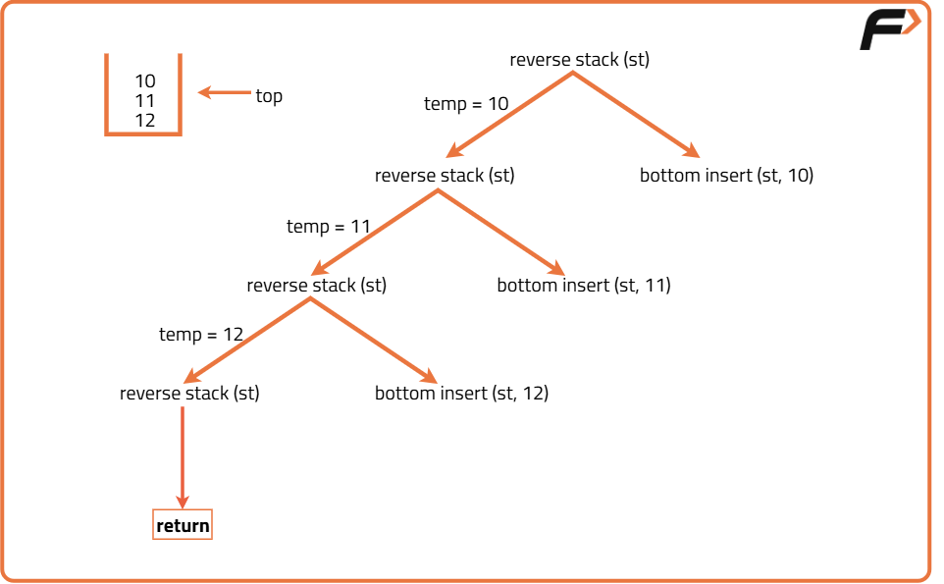
import java.util.*;

class Solution {
// Function to insert an element at the bottom of the stack
public static void insertAtBottom(Stack<Integer> st, int val) {
// If stack is empty, push the value
if (st.isEmpty()) {
st.push(val);
return;
}

// Pop the top element
int topVal = st.pop();

// Recurse for the rest of the stack
insertAtBottom(st, val);

// Push the popped element back
st.push(topVal);
}

// Function to reverse the stack
public static void reverseStack(Stack<Integer> st) {
// Base case: If stack is empty, return
if (st.isEmpty()) return;

// Pop the top element
int topVal = st.pop();

// Recursively reverse the remaining stack
reverseStack(st);
// Insert the popped element at the bottom
insertAtBottom(st, topVal);
}
}
Time Complexity: O(n²), as each element is popped and inserted at the bottom (O(n) per element).
Space Complexity: O(n), as only the recursion stack is used.

